# Appendix -3: Facility Numbers

|  |  |  |  |
| --- | --- | --- | --- |
| **#** | **Program Title** | **Submitting Hospital** | **Facility Number** |
| 1 | Stem Cell Transplant | Hamilton Health Sciences Corporation | 942 |
| Kingston General Hospital | 693 |
| London Health Sciences | 936 |
| Sudbury Regional Hospital | 959 |
| The Ottawa Hospital | 958 |
| University Health Network | 947 |
| Trillium Health Partners | 975 |
| Sunnybrook Health Sciences Centre | 953 |

# Appendix-11: Valid 2-digits Postal Codes

(Source: Cancer Care Ontario's Data Book - 2012-2013, Appendix B - Province and State codes, at link https://www.cancercare.on.ca/ext/databook/db1213/databook.htm).

The table below provides list of valid 2 digit postal codes for province and State codes.

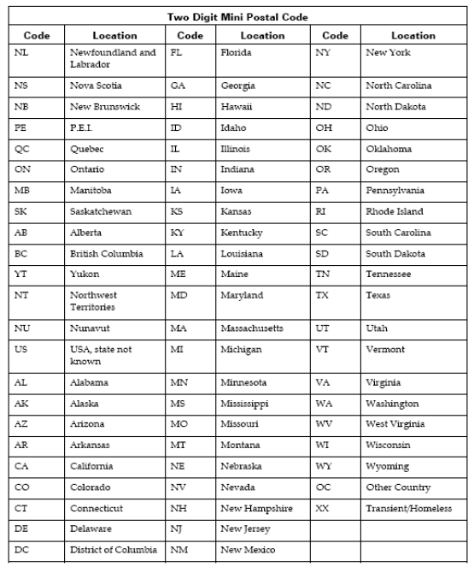

# Appendix 12B: SCT Disease Indication Classification

(Source: Cancer Care Ontario's Data Book - 2012-2013, Appendix 12.1 - SCT Disease Indication Classification, at link https://www.cancercare.on.ca/ext/databook/db1213/databook.htm).

|  |  |
| --- | --- |
| **Name** | **Description** |
| AML /APL | Acute Myeloid Leukemia (including Acute promyelocytic leukemia (APL)) |
| ALL | Acute Lymphoblastic Leukemia  (including lymphoblastic lymphoma) |
| AcuteLeukemiaOther | Acute leukemia other |
| CML | Chronic Myeloid Leukemia |
| CLL | Chronic Lymphocytic Leukemia |
| MDS/MPD | Myelodysplastic / Myeloproliferative Disease |
| MM | Multiple Myeloma |
| Amyloidosis | Amyloidosis |
| NHL | Non-Hodgkin's Lymphoma |
| HL | Hodgkin's Lymphoma |
| SAA | Severe aplastic anemia |
| Solid-Sarcoma | Solid tumours - Sarcoma |
| Solid-GermCell | Solid tumours - Germ cell tumours |
| Solid-Other | Solid tumours - Other |
| Other | Transplant indication not listed above |

# Appendix -13: MOHLTC Master Numbering System

The Master Numbering System has been developed for the purpose of bringing together all Health Facilities and Programs under one system of identification. The list is a composite of health and health related units, facilities, clinics, programs and services. Each such organization has been assigned a unique four digit identifying code.

(For details, please refer Cancer Care Ontario's Data Book - 2012-2013, Appendix A: MOHLTC Master Numbering System, at link <https://www.cancercare.on.ca/ext/databook/db1213/documents/Appendix/CCO_Appendix_A_APR_12.pdf>).

# Appendix -26: Reason Patient Did Not Proceed

* Disease Progression
* Donor Unavailability
* Inadequate Stem Cell Yield
* New Donor
* Patient Comorbidity
* Patient Preference
* Other